Business Problem: Where and why Late Delivery happens, and Rule-based Delivery Risk scoring framework
- Provide end-to-end analysis from fetching data to deliver insights
- Deliver automatic ETL process when refresh occurred as business data changes
- Identify late delivery drivers, including sellers, customers, products, stages of orders
- Develop transparent, rule-based risk score to alert for high risk orders
ETL pipeline:
- Fetching data from Kaggle (Olist Brazilian E-commerce dataset) with Python API (Kaggle API with environment variables configured)
- Download tables locally and import it into SQL server
- Apply data cleaning both before and after importing data into SQL server
- Use Windows Task Scheduler to schedule ETL pipeline bat file
Data Cleaning:
Before importing into SQL server:
- Standardized columns name and string values: Strip spaces, lowercase, replace spaces with underscores, Remove special characters, unify encoding method
- Convert data type: Dates->datetime, Monetary and numeric columns->float/ Int, ID & category columns->string
- Unify missing values as NaN to be recognized by SQL server
- Rename column name
- Remove duplicate record according to primary keys (no primary keys for geolocation table)
After importing into SQL server:
- Remove duplicates for geolocation tables
- Replace missing value using mode for string, median for int, avg for float except
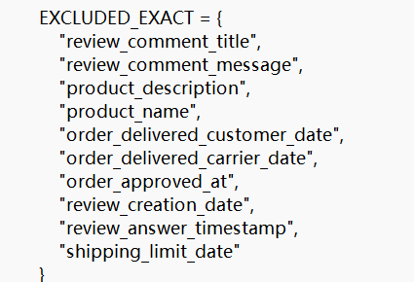
as empty dates suggest incomplete orders, and some string columns are not suitable to replace missing values
- No joining tables because granularity needs to be unified
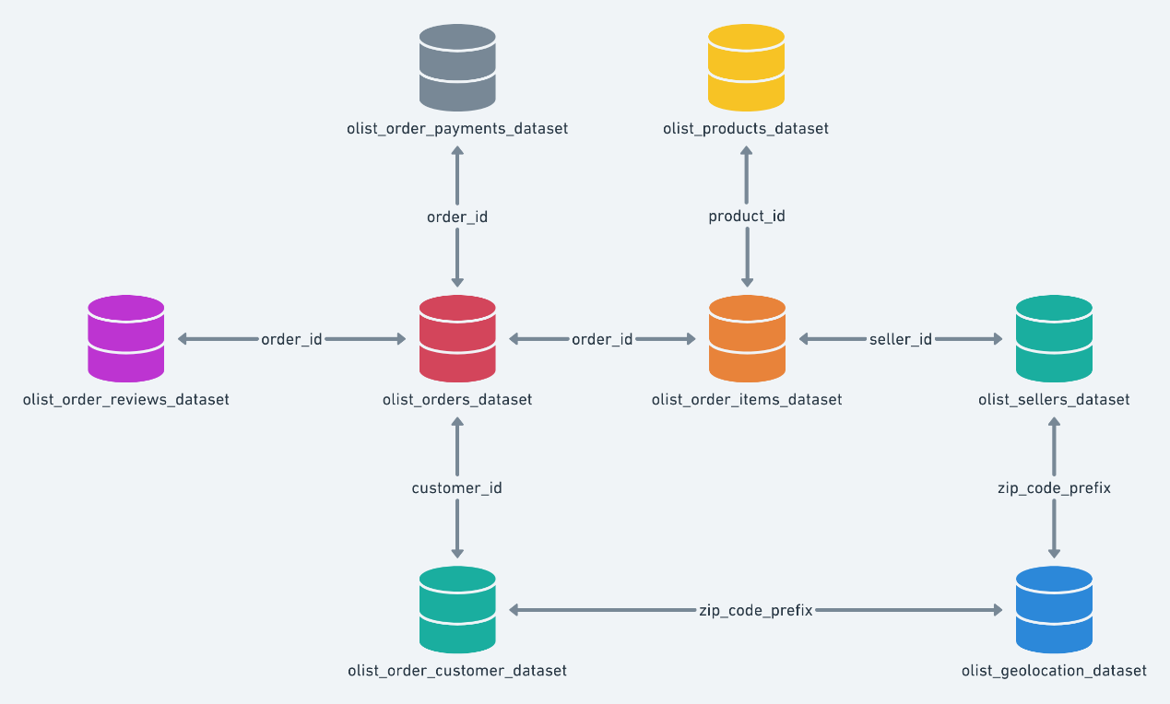
Import data in Power BI:
- using DirectQuery mode for fact tables (orders and orders_items) and import mode for fact tables
- Rename columns and tables without underscores and capitalize first letter
- Duplicate geolocation tables for customers and sellers
- Convert all Datetime type into Date for relationship building
Building semantic model:
- Create date tables and a copy of date tables named date delivered to build relationship with order delivery customer date specially
- Build relationship for tables according to the table structure as the image shows
- Create measures: Late rate, Avg late days, Sample Size, Order Approval Days, Avg Handling Days, Shipping Days, Avg Estimated Days, Risk Score related measures etc.
Visuals:
- Late Rate & Avg Late Days by Sellers, Customers, Products and Delivered Date with sample size larger than 10
- Comparison of seasonality pattern across different timestamps
- Drillthrough pages for sellers, customers, products and delivered date
- Risk score page for incomplete orders to evaluate their sellers, products, Customer state and Approval Days.
Explanation of visuals and measures:
- Risk score page only include measures calculating incomplete orders, while measures of other pages only include complete orders
- Late Rate late orders and punctual orders and returning blank for incomplete orders, using sample size (complete orders) to count
- Avg Late Days only calculate late orders and returning blank for incomplete orders and punctual orders, using sample size (late) to count
- All visuals are filtered by either sample size(complete orders) or sample size (late) that larger than 10
- Visuals with flat bars across all value of the input variable that provide no insights are deleted
- Purchase timestamp: Date when the order is purchased
- Approved Date (Order Approved At): Date when the order is approved
- Delivery Date (Order Delivered Carrier Date): Date when the seller delivers the product
- Shipping Limit Date: Date is required before when the seller delivers the product
- Delivered Date (Order Delivered Customer Date): Date when the customer receives the product
- Order Estimated Delivery Date: Date is required before when the customer receives the product
- Review Creation Date: Date when the review is created
- Review Answer Date: Date when the customer writes the review
- Avg Estimated Days: Avg days between Purchase Date and Order Estimated Delivery Date
- Avg Order Approval Days: Avg days between Purchase Date and Approved Date
- Avg Handling Days: Avg days between Approved Date and Delivery Date
- Avg Shipping Days: Avg days between Delivery Date and Delivered Date
- Seller Sate Late Rate & Seller State Avg Late Days: the seller’s state late rate and avg late days
- Sample Size Sufficient for Analysis: Number of complete orders is larger than 10
- Late mainly driven: determined by the largest number among Avg Estimated Days, Avg Order Approval Days, Avg Handling Days and Avg Shipping Days
- State Late Rate: the customer’s state late rate and avg late days
- Category Late Rate: the product’s category late rate and avg late days
- Risk + 1 if Any Seller > P80: Orders provided by a seller (anyone of all sellers in an order) whose late rate is larger than 0.8 percentile of all sellers score + 1
- Risk + 1 if Any State > P80: Orders delivered to a state (any state of all customer states in an order) with late rate being larger than 0.8 percentile of all states score + 1 (order sample size of a same customer is small, so use customer state instead)
- Risk + 1 if Any Product > P80: Orders having a product (any product of all products in an order) with late rate larger than 0.8 percentile of all products score +1
- Risk + 1 if Avg Approval Days > 2: Orders having Approval Days larger than 2 days score + 1
- Handling Days is not used as a risk score rule as it is highly related to sellers and products
Insights:
Late delivery is highly related to customers satisfaction. With higher late rate and avg late days, customers review scores are lower.
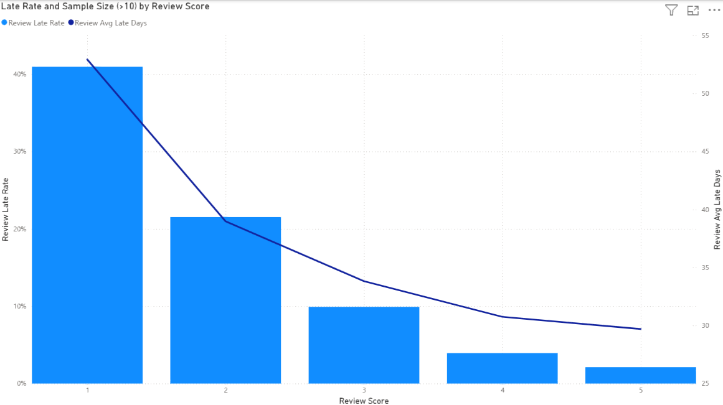
Except for a few sellers that have both high late days and late rate, most of the late sellers have either high late days or high late rate
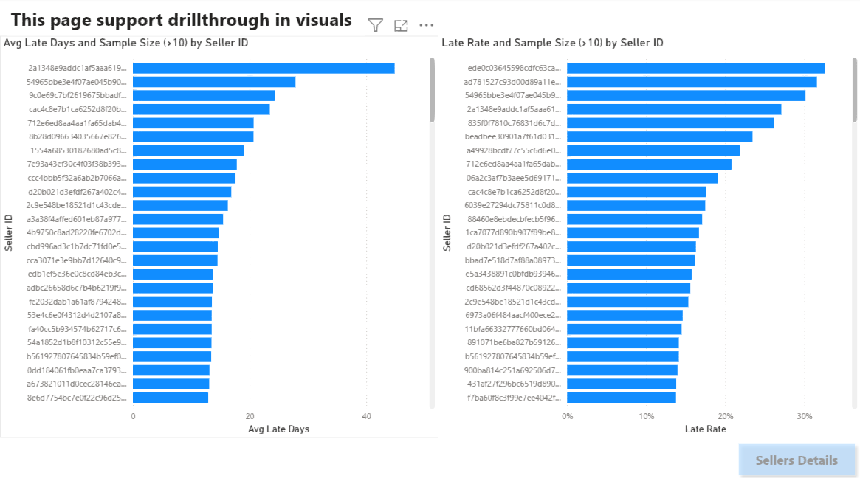
The products weight exhibits positive relationship with late rate and late days. The heavier products tend to be delivered lately to customers (not included in Risk Score because it will be counted repeatedly after scoring product ID)
Except for a few products categories that have either high late days or high late rate, most of the late product’s categories have both high late days and late rate
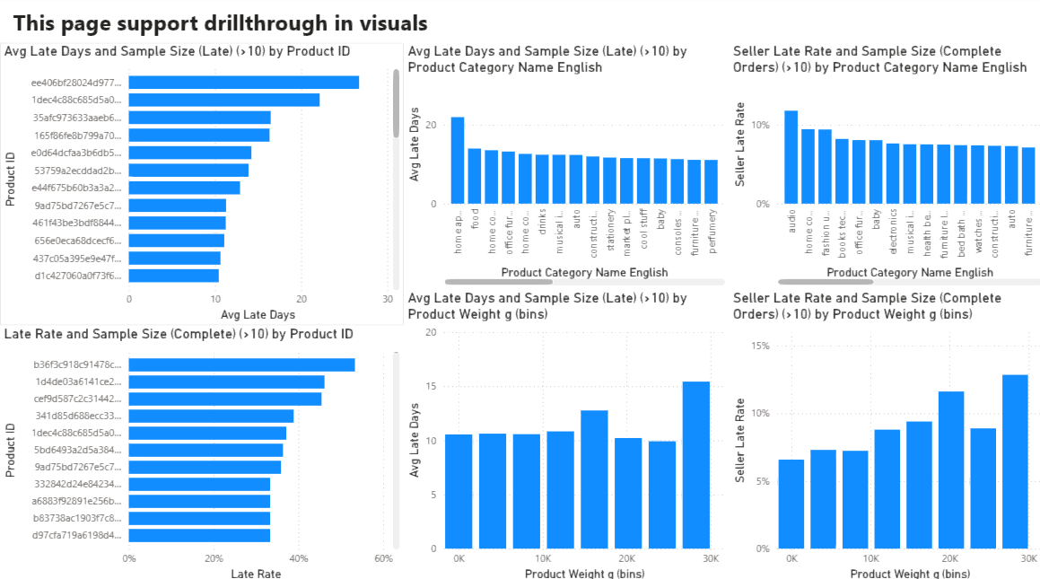
Customer state is more reliable than individual customer as most customers has fewer than 5 orders. State-level provides more useful information.
There are states that has low late rate but high avg late days, reflecting extreme risks in some states
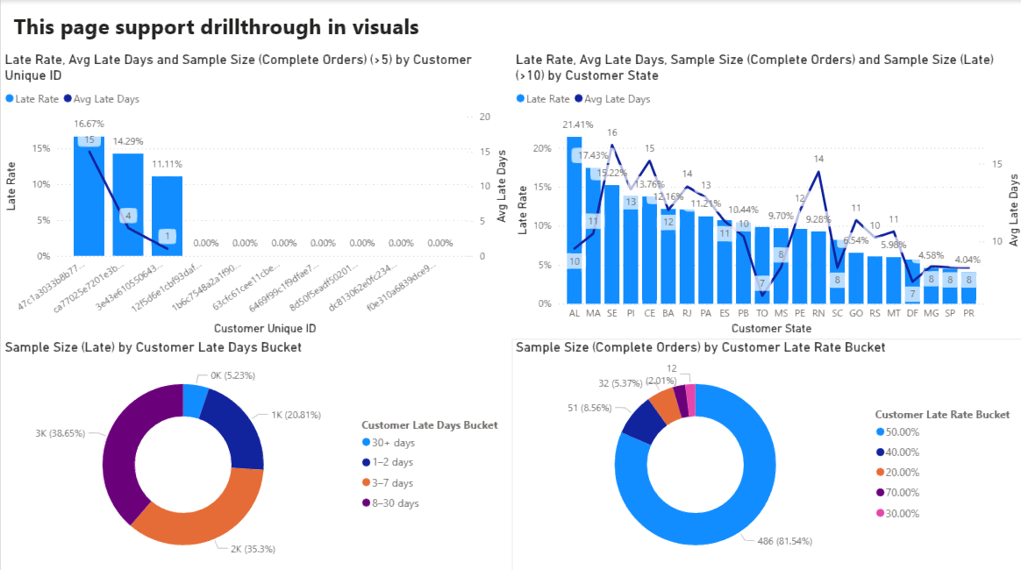
Q3 exhibits low late rate but high late days, indicating instability of that quarter. Other quarters have same rank in late rate and late days.
Late Rate is higher when orders are delivered on Saturday and Sunday
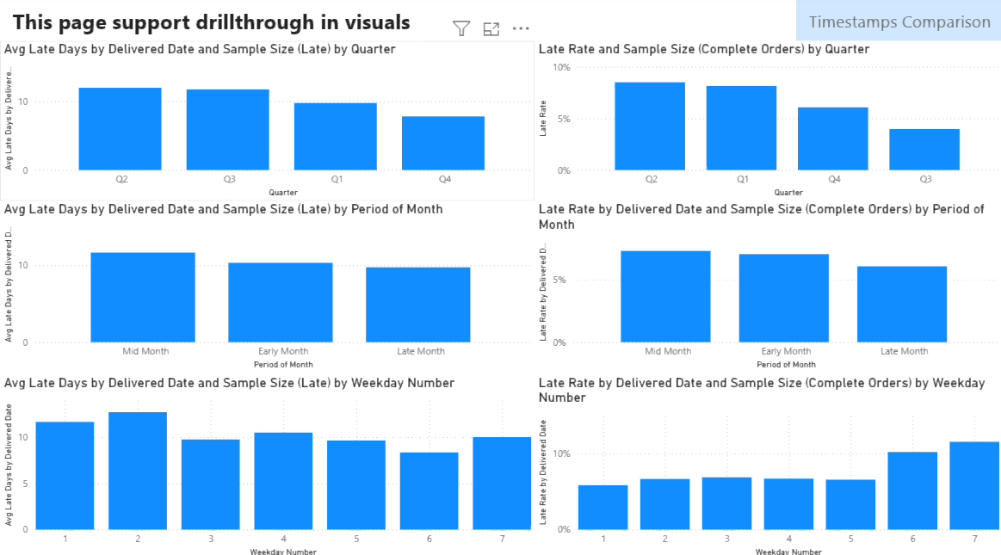
Q1 shows highest late risk across almost all timestamp, indicating systematic high risk in the quarter, while Q3 shows stable lowest risk in all timestamps.
Seasonality pattern changes most significantly between delivery date and delivered date, indicating higher uncertainty in the shipping stage than other stages

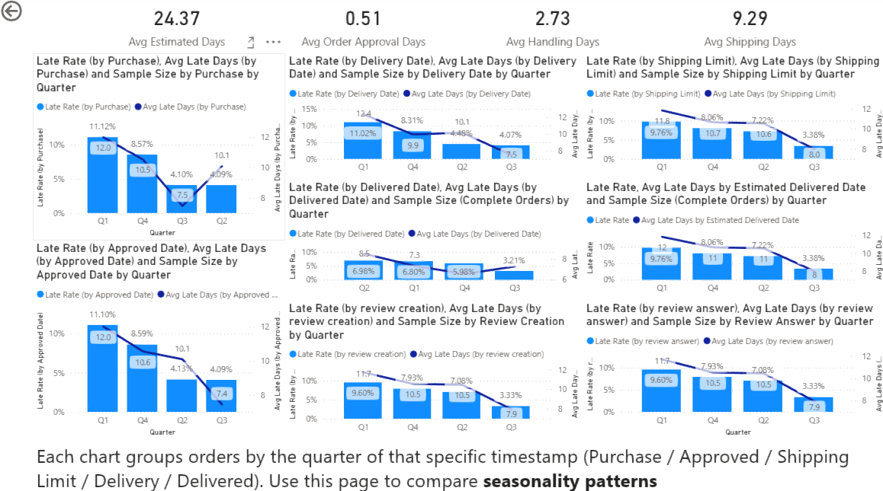
Risk Score:
Alert for each orders and display score elements in the page
